Physics 30 Lesson 37 Particle Physics

“The stumbling way in which even the ablest of the scientists in every generation have had to fight through thickets of erroneous observations, misleading generalizations, inadequate formulations, and unconscious prejudice is rarely appreciated by those who obtain their scientific knowledge from textbooks.”

James Bryant Conant

The concept that matter is composed of elementary building blocks originated with Democritus (circa 500 BCE). By the early 1800s, with acceptance of Dalton's atomic theory, the atom was consid­ered to be elementary. Indeed, the term element is still used when referring to the 103 or so different known atoms. By the early 1900s, the discovery of the electron and the basic sub­atomic structure of the atom indicated that the electron, proton, and neutron were the elementary particles. By the mid 1930s, the photon, positron, and neutrino were also considered to be ele­mentary. Since 1970, the existence of over 300 such particles has been firmly established, and several models describing the relations among them have been developed. The question arises then, what particles are elementary? It is this question that challenges participants in the field of physics known as **elementary particle physics**.

# Particle detectors

Subatomic particles are far too small and move too fast to be observed and measured directly. Also, most elementary particles decay into smaller particles very quickly – i.e. 10-24 to 10-9 s. In order for a detector to sense a particle, there must be an interaction between the particle and the material of which the detector is made. This interaction produces a response. The three primary responses are: the emission of light, the ionization of the medium, and a phase or chemical change in the medium. We will describe only two of the detectors used in high-energy research – the cloud chamber and the bubble chamber. Refer to Pearson pages 830 to 835.

The **cloud chamber** was invented in 1911 by Charles Wilson, a Scottish physicist (1869-1959). Wilson found that in a gas supersaturated with a vapour, the vapour will condense into droplets around the trajectories of charged ions as they pass through the gas. The ions leave behind trails of droplets which can be photographed.

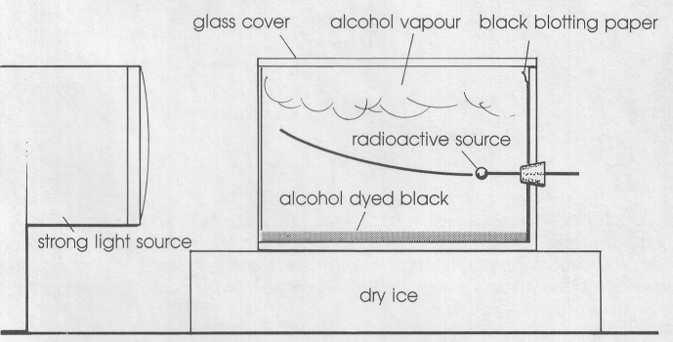A simple cloud chamber can be made with a glass or plastic cylindrical container, open at one end. A piece of black cloth saturated with alcohol is placed on a block of dry ice and then covered by the glass container. The container soon fills with alcohol vapour, and a super­saturated layer of alcohol forms just above the black cloth. If a radioactive source, emitting alpha or beta particles, is put into the container, the moving

particles will leave vapour trails behind them as they condense the alcohol vapour. The effect is similar to contrails (vapour trails) left by commercial jet aircraft passing high overhead.

In the **bubble chamber**, liquid propane, hydrogen, helium, and xenon are all used. However, liquid hydrogen is used most commonly since the hydrogen nuclei provide target protons for collisions. The liquid hydrogen must be kept below –252.8°C to remain liquid. If the pressure in the liquid hydrogen is suddenly lowered, however, the hydrogen boils. If a high-speed charged particle passes through the hydrogen at exactly the same instant, hydrogen ions are formed, and the hydrogen boils a few thousandths of a second sooner around these ions than in the rest of the container.

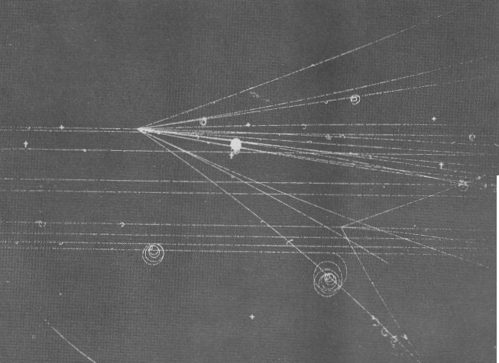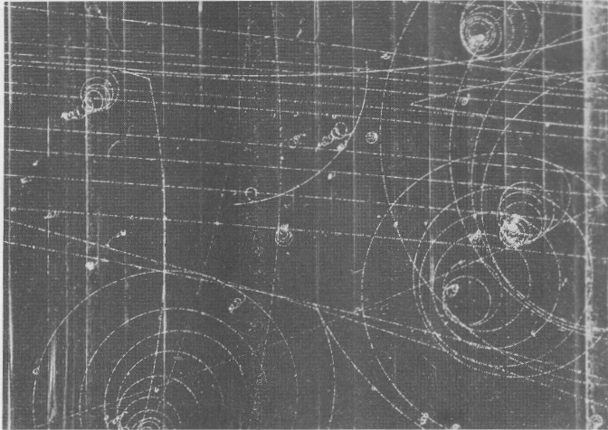

Carefully timed photographs record the paths of the resulting bubble trails. Frequently a magnetic field is applied across the chamber, bending the paths of the charged particles. Positive particles are curved in one direction, negative particles in the other. By measuring the curvature of their paths and knowing the strength of the magnetic field, the charge to mass ratio of the particles can be determined.

Only charged particles and ionizing photons will create tracks in a cloud or bubble chamber. Neither neutral particles nor low-energy photons will be detected. However, it is possible to calculate some of the properties of neutral particles from the tracks of charged particles that interact with them.

# Antiparticles

As mentioned in Lesson 36, Carl Anderson was the first to observe the positron. In his experiment, high-energy cosmic rays, consisting of highly energetic gamma ray photons, passed through a cloud chamber. When these photons collided with the nuclei within a thin lead plate, electrons and positrons were created simultaneously in a process called **pair production**.

In pair production, a photon interacts with a nucleus, the photon ceases to exist, and an **electron-positron pair** is created.



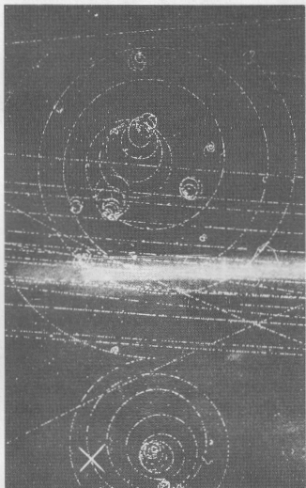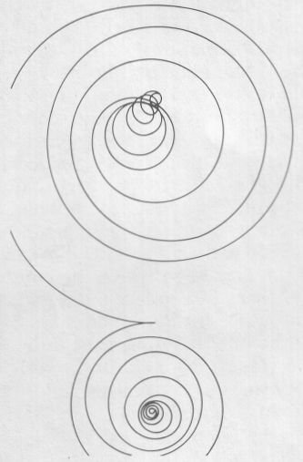

Photograph of electron-positron pair production in a bubble chamber.

A drawing of the electron-positron pair from the photograph. Note that the particles spiral in opposite directions in the external magnetic field.

Note that there is no trace of a gamma ray until it collides with a nucleus.

For electron-positron pair production to occur two things must happen. First, a photon must collide with a nucleus causing the photon’s energy to be transformed into particles – i.e. a photon cannot spontaneously decay into a pair. Second, the conservation of mass-energy requires that the minimum photon energy must be equal to the rest mass of an electron plus a positron. Refer to Pearson pages 836 to 837.



What is the minimum frequency of a photon required to produce a stationary electron positron pair?

We can calculate the rest energy of an electron/positron using E = mc2.



For an electron and a positron to be created, the photon must have a minimum energy of

2 x 8.187107 x 10-14 J = 1.6374214 x 10-13 J.

Calculating the frequency of the photon:



But if positrons are formed in + decay and in pair production, why are they not normally found in nature? The positron, like the electron, is a stable particle. However, the positron finds itself in the company of zillions (physics technical term meaning “lots”) of electrons. Under normal conditions, a positron will collide with an electron within a millionth of a second. When particle meets an­tiparticle they annihilate (destroy) one another and energy in the form of photons is emitted. This process is known as **pair annihilation**, the direct conversion of mass into electromagnetic energy. It is the inverse of pair production. The conservation laws of energy, linear momentum, angular momentum, and charge predict that two photons are emitted in opposite directions and with opposite spins. This has been verified experimentally.

•

•

e+

e–

before

after







Having discovered positrons and predicted antineutrinos, phy­sicists began to speculate about other kinds of antiparticles. In fact, it was possible to imagine a world of antimatter, where positrons moved in Bohr orbits around nuclei containing negatively charged antiprotons. It would be difficult to visibly distinguish such an antimatter world from our world, because the physical behaviour of antimatter atoms would be the same as that of ordinary atoms. However, if antimatter and ordinary matter came into contact, they would annihilate each other with an explosive release of energy.

Theorising an antiproton is one thing, producing one is another. Since a proton is 1840 times as massive as an electron, the energy required to produce an antiproton would have to be 1840 times greater than that of the cosmic rays that produce positrons – i.e. about two thousand million electronvolts (2 GeV)! Physicists had to wait until extremely high-energy particle ac­celerators were built before they could generate antiprotons. When these accelerators were built, the expected results occurred, and a host of other particles and antiparticles were observed.

The production of heavier particles and the need to probe deeper into what matter is made of requires larger and larger accelerators. Today there are accelerators that give particles energies of over 2000 GeV or 2 TeV. The Tevatron particle accelerator at the Fermi National Accelerator Laboratory was designed to force two beams of particles (protons and antiprotons) to smash into each other. The newest and grandest accelerator so far is the Large Hadron Collider (LHD) which will operate at 14 TeV. Refer to Pearson pages 840 to 842.

# Nuclear forces

Soon after the nucleus was discovered there arose an obvious question: Since a group of positively charge particles must repel each other, what holds the nucleus together? A simple calculation of the repulsion between two protons separated by a distance that puts them just about in contact in the nucleus (≈ 10-15 m) yields a repulsion value of around 230 N. This is an enormous force when we consider the mass of a proton. By 1925, there was recognition that a new kind of force was needed. The **strong nuclear force** binds neutrons and protons together to form nuclei. It has an effective range of 1.0 x 10-15 m and can have energies of as much as 100 MeV. While the strong force is attractive for distances around 1.0 x 10-15 m, it is repulsive at distances less than 0.5 x 10-15 m (i.e. – two nucleons cannot occupy the same space.)

The strong force, which is the most potent of all interactions, is about 100 times stronger than the electromagnetic force and is 1038 times stronger than the gravitational force.

|  |  |  |  |  |  |
| --- | --- | --- | --- | --- | --- |
| *The Four Forces of Nature***\*** | |  |  |  |  |
| **Force** | **Interacts between** | **Relative strength** | **Effective range** | **Mediating particles** | **Particle observed?** |
| Gravitational | All mass-energy | 10-34 | Unlimited | gravitons | no |
| Weak nuclear | All material particles  (quarks and leptons) | 10-2 | ≈ 10-17 m | W+, W–, Zo | yes |
| Electromagnetic | Electromagnetic charges | 102 | Unlimited | photons | yes |
| Strong nuclear | Many sub-nuclear particles  (quarks and gluons) | 104 | ≈ 10-15 m | gluons | indirectly |

*The strengths (in Newtons) are for two protons separated center-to-center, by 2 x 10-15 m.

However, if the strong force is so dominant, why are some nuclei unstable while others are not? There are two reasons for the instability of some nuclei. First, the strong force has a very short effective range. If nucleons become too close the force is repulsive and if they are too far apart the force becomes too weak. The larger the number of nucleons the greater the distance between the furthest protons in the nucleus. Eventually the distance becomes too large for the strong force to overcome the electrostatic repulsion, resulting in the nucleus decaying into smaller nuclei. Second, some nuclei are unstable due to the action of the exotic and destabilizing **weak nuclear force**. This is based on a 1934 theory by Enrico Fermi which explains how neutrons can convert to protons and vice versa. It explains the beta decay (see Lesson 36) of many nuclei. (Refer to Pearson page 792 to 793 and page 838.)

# Fields and particle interaction (optional)

Prior to the introduction of Quantum Mechanics, particles and fields were considered interrelated though distinct entities; particles possessed intrinsic features (for example, mass and/or electromagnetic charge) that gave rise to external fields (for example, gravitational and/or electromagnetic). Force fields emanated from parti­cles and filled the surrounding space. They carried energy and were, in a sense, real continuous media that interconnected all interacting particles and mediated their in­teractions. Particles were composed of matter, fields were composed of energy. But particles that do not react to any force fields are unobservable and physically meaningless. Similarly, force fields that do not act upon any particles are equally without significance. The ideas of **particle** and **field** take meaning from their **interrelationship**.

The concept of field began to change drastically with the introduction of Einstein's photon. The electromagnetic field does not, after all, have its energy continuously spread out in space. **The photon is the quantum of the electromagnetic field, and it carries the energy and momentum of the field**. Thus, the interaction of two charged particles must take place through the exchange of photons. **Quantum Electrodynamics** (QED), the theory of such interactions, was the first successful application of these ideas.

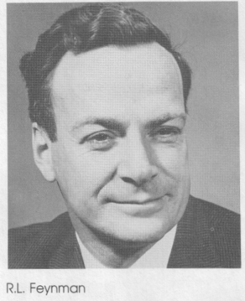Richard L. Feynman (1918-1988), an American physicist, developed the concept of a space-time diagram to illustrate such QED interactions. The simplest case occurs when only one photon is exchanged. Consider the inter­action of two electrons. One electron may be considered to create a photon and the other may be considered to absorb the photon. Each of the electrons undergoes changes in energy and momentum because of the exchanged photon, and the electrons repel each other. As an analogy, think of the repulsive interaction between two astronauts floating in space throwing a ball back and forth. The electrons' exchange interaction is a quantum effect and cannot be visualized in classical terms. Still, repulsion by way of an exchange force can be thought of via the astronaut-ball analogy. However, attraction between an electron and a proton through exchange is unvisualisable, unless you resort to nonsense like the astronauts facing away from each other catching boomerangs backwards so that they're pushed together. Feynman diagrams are symbolic and they are not concerned with accurately picturing the particle trajectories. The important part is the interaction.

e–

e–

e–

e–

But wait a minute!! While the energy of either electron is unchanged throughout the interaction, during the time that a photon moves from one electron to the other, the system contains an additional amount of energy (hf) corresponding to the photon. For a time, Conservation of Energy is seemingly violated! Can this situation be tolerated? One answer offered by modern physics is yes, provided the photon can never be observed. In other words, the Heisen­berg Uncertainty Principle tells us that there is always some uncertainty (E) in the measured value of the energy of a system. Nonconservation of energy up to an amount E will be hidden by the ever-present energy uncertainty, provided the time available to make the observation is restrictively small. (If a moment of nonconservation is totally unobservable, is Conservation of Energy actually violated?) Such unobservable exchange quanta are called **virtual photons**. Refer to Pearson pages 837 to 838.

In contrast to real quanta, these virtual quanta are the messengers of the interaction. In the Feynman diagrams, they are the internal segments that begin and end within the figure. They effectively “tell” the material particles what is happening. A photon that is observable in the sense that it is detected by an eyeball or a Geiger counter is real enough. A photon that never leaves the region of interaction between charges and vanishes in the process of communicating the electromagnetic force – a photon that cannot therefore be seen by a detector so that we never observe any violation of the basic conservation laws – is a virtual photon.

Draw a Feynman diagram for the interaction between an electron and a proton.

e–

p+

p+

e–

Photons mediate electromagnetic interactions. A Feynman diagram indicates the exchange of a virtual photon that mediates the interaction, in this case attraction.

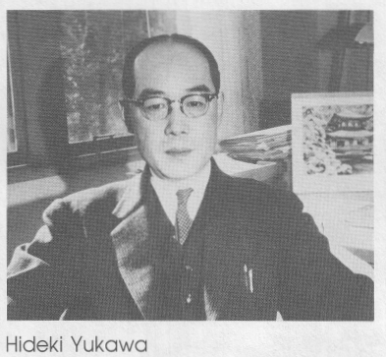In 1934, the Japanese physicist Hideki Yukawa (1907-1981) proposed that, like the electromagnetic force being mediated by virtual photons, the **strong interaction** was mediated by the exchange of a massive virtual **boson**. (A boson is the general term for a force carrier particle and it is named after the Indian physicist Satyendra Nath Bose.) Yukawa predicted that this new particle, named a **meson**, would have a rest mass of 270 *me* (electron masses). He also predicted that since photons can be observed as free particles as well as being involved in an electromagnetic interaction, so a free meson should be observable. In 1934, the only source of sufficient energy was cosmic radiation and it was not until 1947 that it became possible to study high-energy cosmic-ray collisions using photographic emulsions. In that year, Yukawa's particle was found and it was named the ** meson**, or **pion**. Pions were found to exist in two varieties + and – and to have a rest mass of 274 *me* as Yukawa had predicted. These particles were later produced artificially, using a particle accelerator, and a third o meson was discovered, a neutral one, with a slightly smaller mass of 264 *me*. Free  mesons are unstable and quickly decay (in 10–8 s).

It was proposed that virtual particles, emitted and absorbed, constantly fly back and forth between nucleons which, in turn, are transformed – the proton and neutron are two alternative states of the nucleon. Below are Feynman diagrams of nucleon-nucleon interactions through the exchange of virtual pions.

p

n

p

n

+

proton-neutron interaction

n

n

n

n

o

neutron-neutron interaction

n

p

n

p

–

neutron-proton interaction

Since the discovery of the pion a number of other mesons have been dis­covered and these too were thought to mediate the strong nuclear force. However, we now believe that meson exchange between nucleons is actually a low-strength residual manifestation of a still more basic and more powerful interaction involving the exchange of gluons among quarks (see Lesson 38).

# Classification of particles (optional)

More than 150 years ago, scientists recognized that elements could be arranged in groups according to their chemical properties which resulted in the periodic table of elements. As more and more subatomic particles were discovered, it was found that they too could be organized into groupings according to their properties. Refer to Pearson pages 842 to 843.

It is useful to group the known particles into three families, the photons, the leptons, and the hadrons, as the table below summarises. This grouping is made according to the nature of the force by which a particle interacts with other particles. The **photon family**, for instance, has only one member, the photon. The photon interacts only via the electromagnetic force and no other particle behaves in this manner.

The **lepton family** consists of particles that interact by means of the weak nuclear force. Leptons can also exert gravitational and electromagnetic (if the leptons are charged) forces on other particles. The four better-known leptons are the electron, the muon, the electron neutrino e, and the muon neutrino . In 1974 and 2000, two other leptons were discovered, the tau particle () and its neutrino (), bringing the number of particles in the lepton family to six.

The **hadron family** contains the particles that interact by means of the strong nuclear force and the weak nuclear force. Hadrons can also interact by gravitational and electromagnetic forces, but at short distances (< 10-15 m) the strong nuclear force dominates. Among the hadrons are the proton, the neutron, and the pions. As the table indicates, most hadrons are short-lived. The hadrons are subdivided into two groups, the mesons and the baryons, for reasons that will be discussed in connection with the idea of quarks.

|  |  |  |  |  |  |  |  |  |
| --- | --- | --- | --- | --- | --- | --- | --- | --- |
| Name | | particle | particle  symbol | antiparticle symbol | Spin | Rest Mass  (in me) | Rest Energy  (MeV) | Lifetime  (s) |
|  | Photon | photon |  |  | 1 | 0 | 0 | stable |
|  | Leptons | electron |  |  | ½ | 1 | .511 | stable |
| electron neutrino |  |  | ~0 | ~0 | stable |
| muon |  |  | 207 | 105.7 | 2.2 x 10-6 |
| muon neutrino |  |  | ~0 | ~0 | stable |
| tauon |  |  | 3477 | 1784 | 2.9 x 10-13 |
| tauon neutrino |  |  | <47 | <24 | stable |
| Hadrons | Mesons | ❐ mesons  (pions) |  |  | 0 | 274  264 | 139.6  135.0 | 2.6 x 10-8  8.4 x 10-17 |
| K mesons  (kaons) | K+  Ko | K– | 966 | 493.7 | 1.2 x 10-8 |
| 974 | 497.7 | 9 x 10-9 |
|  meson  (eta) | o | o | 1074 | 548.8 | <10-18 |
| psi |  |  | 6061 | 3097 | 8 x 10-21 |
| upsilon |  |  | 18513 | 9460 | 1.3 x 10-20 |
| Baryons | proton | p |  | ½ | 1836 | 938.3 | stable |
| neutron | n |  | 1839 | 939.6 | 885 |
| lambda |  |  | 2183 | 1116 | 2.6 x 10-10 |
| sigma |  |  | 2327 | 1189 | 0.8 x 10-10 |
|  |  | 2334 | 1192 | 6 x 10-20 |
|  |  | 2343 | 1197 | 1.5 x 10-10 |
| xi |  |  | 2573 | 1315 | 2.6 x 10-10 |
|  |  | 2586 | 1321 | 1.6 x 10-10 |
| omega |  |  |  | 3272 | 1672 | 8.2 x 10-10 |

In addition to the names and classes in the table, particles that have half-integer spin, such as  or , (i.e. leptons and baryons) are called **fermions**, while particles that have integer spin, such as 0, 1, or 2, (i.e. mesons and mediating particles) are called **bosons**.

# Practice problems

1. Why is it difficult to detect a neutrino?

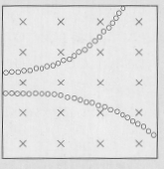2. Determine the type of charge on each particle moving through the magnetic field in this diagram. What information would you need to determine which particle is moving faster?

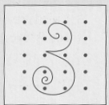3. The tracks in this diagram show the creation of two particles in a bubble chamber. Initially, the two particles have the same speed.

(a) What evidence suggests that a photon created the two particles?

(b) Describe the path of this photon.

(c) Which of the tracks shows the path of a positively charged particle?

(d) Give two reasons why the other track must show the path of a negatively charged particle.

(e) How are the mass and charge of the two particles related?

(f) Why is it likely that the interaction involves an antiparticle?

4. Find the energy equivalent of the mass of a neutron.

# Hand-In Assignment

1. Compare the process for forming tracks in a cloud chamber with the process in a bubble chamber. Bubble chambers have replaced cloud chambers in many research laboratories. What advantages do bubble chambers have over cloud chambers?

2. What kinds of subatomic particles will leave tracks in a bubble chamber and what kinds will not leave tracks in a bubble chamber.

3. Why is a magnetic field often applied across a cloud or bubble chamber? What can the curvature of a particle's track in a magnetic field reveal about the particle?

4. Describe and explain the differences in the tracks made in a bubble chamber by the particles in each pair:

(a) protons and alpha particles

(b) protons and electrons

5. Which fundamental force is the strongest over large distances? Which fundamental force is the weakest at nuclear distances?

6. How does quantum field theory account for fundamental forces acting over a distance?

7. What event is represented by the equation ? Why is the event  not possible?

8. Under what conditions will two protons attract each other? Under what conditions will they repel each other?

9. Can alpha particles from the radioactive decay of polonium be used to probe (a) the atom and (b) the nucleus? Explain your answer.

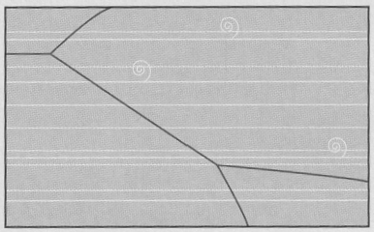10. The dark tracks in this diagram show a high ­speed proton colliding with a hydrogen atom in a bubble chamber, deflecting downward, and then colliding with another hydrogen atom. These tracks curve clockwise slightly.

(a) In which direction is the magnetic field oriented?

(b) What conclusions can you make about the mass, speed, and charge of the particles involved in the first collision?

(c) What conclusions can you craw about the mass, speed and charge of the particles that made the small spiral tracks.

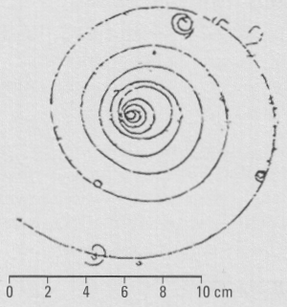11. The diagram shows a particle track recorded in a bubble chamber at the CERN particle accelerator. The magnetic field in the bubble chamber was 1.2 T directed out of the page.

(a) Does the particle have a positive or negative charge? Explain your reasoning.

(b) Estimate the initial radius of the particle's path.

(c) Determine the initial momentum of the particle.

(d) Why does the particle's path spiral inward?

(e) What could cause the short tracks that branch off from the large spiral track?

12. The mass of a psi particle is 3.097 GeV/c2. Express this mass in kilograms.

13. What is the energy of the antielectron neutrino, if a phosphorus-32 atom (31.97390 u) beta-decays into a sulphur-32 atom (31.97207 u), and the kinetic energy of the accompanying electron is 0.90 MeV? (0.39 MeV)

14. A boron-12 atom (12.01435 u) beta-decays into a carbon-12 atom (12.00000 u). What is the maximum kinetic energy of the emitted electron? (12.89127 MeV)

15. In the + decay of carbon-12 (12.00000 u) into nitrogen-12 (12.01864 u), a positron with a kinetic energy of 11.0 MeV is emitted. What is the energy of the electron neutrino? (6.92 MeV)

16. 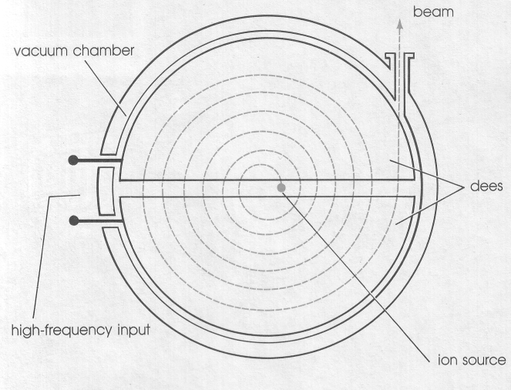Ernest Lawrence, an American physicist, invented the cyclotron to accelerate particles. An ion source is located in the middle of an evacuated chamber in the shape of a short cylinder. This chamber is positioned between the poles of a strong electromagnet, which creates a uniform magnetic field per­pendicular to the flat surfaces of the chamber. Inside the evacuated chamber are two hollow electrodes, called dees because they are shaped like the letter "D". An alternating potential difference, which operates at a frequency equal to the orbital frequency of revolution of the particles in the magnetic field, is applied between the dees. The acceleration occurs only in the space between the dee elec­trodes, where the electric fields are concentrated, not inside the dees. Each time a particle crosses the gap between the dees it is accelerated, since the direction of the electric field reverses between crossings. Because the speed of the particle increases with each cycle, the radius of its path increases, and the path is spiral-like until the particle reaches the outside edge of the device. Magnets are used to focus a beam of particles onto a target when the beam exits the cyclotron. If the potential difference between the dees of a cyclotron is 30 kV, how many revolutions do protons have to make in order to reach an energy of 25 MeV? (417)

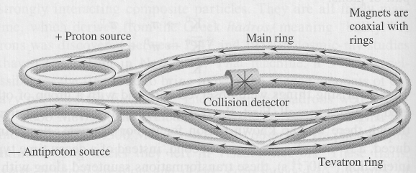17. Protons injected into the Tevatron synchrotron at the Fermilab travel around a circumference of 6.4 km. When they are injected into the synchrotron, they have an energy of 8.0 GeV, but when they leave they can have an energy of 1.0 TeV. If the protons gain 3.0 MeV in each rotation, how many rotations are required and how far do the protons travel? (3.3 x 105 rotations, 2.1 x 109 m)

18. Calculate the energy required to produce a neutron-antineutron pair. (1.88 GeV)

19. An X-ray photon with a frequency of 1.8 x 1018 Hz collides with a nucleus. Will electron-positron pair production occur? Explain your answer.

20. What is the wavelength of the photons produced in electron-positron pair annihilation? (2.43 x 10-12 m)